Proceedings of CHT-12

ICHMT International Symposium on Advances in Computational Heat Transfer

July 1-6, 2012, Bath, England

CHT-12-xxx

**HYBRID EXPERIMENTAL-NUMERICAL APPROACH TO SOLVE**

**INVERSE CONVECTION PROBLEMS**

Joseph VanderVeer and Yogesh Jaluria§

Dept. of Mech. and Aero. Eng., Rutgers University, US

§Correspondence author. Fax: +1 732 445 3124 Email: jaluria@jove.rutgers.edu

**ABSTRACT** A methodology is developed to utilize both experimental and numerical information in solving inverse convection problems. The method is applied to a plume generated by an electrically heated copper block set within a small wind tunnel to provide cross flow. This methodology attempts to solve for, within acceptable error, the source location and source temperature, which are not known a priori. A key factor in practicality of the approach is limited experimental sampling. Results show typical methodology errors of less than 0.1% for source temperature and 5% for source location. Results of combined experimental, experimental-numerical, and methodology errors were found to be typically less than 1% for source temperature and 6% for source location.

# NOMENCLATURE

|  |  |  |  |  |
| --- | --- | --- | --- | --- |
|  |  |  | Subscripts |  |
| b | y-Intercept of linear interpolation |  | 1 | Datum sample |
| E |  |  | A | Simulation A |
| m | Slope of linear interpolation |  | B | Simulation B |
| n | Number of samples |  | i | Sample identifier 1-n |
| $$∆x,∆y,∆z$$ | Mesh spacing of numerical grid |  | SA | Source of simulation A |
| $${∆x}_{i},{∆y}_{i}$$ | Relative location of sample i to datum sample |  | SB | Source of simulation B |
| $$σ,ε/k$$ | Lennard-Jones parameters |  | S | Source to be investigated |
|  |  |  | Superscript * | Mid-methodology prediction |

# INTRODUCTION

Jets and plumes in cross flows appear in many engineering topics of interest. Topics include chimney smoke, fires, and exhaust from vehicles. The forward problem has been thoroughly studied via experiments and simulations and has been reported upon by many people (e.g. Morton [1996], Rudman [1996], Carvel [2001], Mokhtarzadeh-Dehghan [2006], Hu [2009]). The inverse problem, however, has received less attention and is often of more interest to environmentalists, engineers, and fire fighters. The inverse convection problem, like other inverse problems is an ill-posed mathematical construct resulting in infinite non-unique solutions. Many techniques have been developed to reduce the solution set of ill-posed problems to a small subset (possibly unique) of solutions. These techniques are often similar to or derived from Tikhonov's regularization technique (Tikhonov [1977], Özisik [2000], Orlande [2011]).

The current research is an attempt to calculate, within acceptable error, both the location and temperature of a plume source in a cross flow using limited downstream information. The approach uses a hybrid experimental-numerical method in conjunction with traditional regularization techniques to solve for aforementioned parameters. For this methodology to be most practical the experimental data must be limited to a few sample points.

# EXPERIMENTS AND APPARATUS

Experiments are performed using a small wind tunnel with a test section of $54.5x305x254mm$. The large aspect ratio of the wind tunnel $(\sim 5:1)$ encourages two-dimensional flow. The main flow is generated by two 12 Volt DC brushless fans and has a velocity range of $2.0 to 50cm/s$. The fans are located at the anterior of the tunnel to reduce the turbulence induced by the spinning blades. In an attempt to generate uniform flow, four flow straighteners are used. Three straighteners are upstream of the test section and one downstream. The straighteners are a honeycomb structure with each straightener shifted out of alignment from the others. A 2D schematic of the system is shown in figure 1. All dimensions are in millimeters and depth into the page is $305mm$. The flow is from left to right.

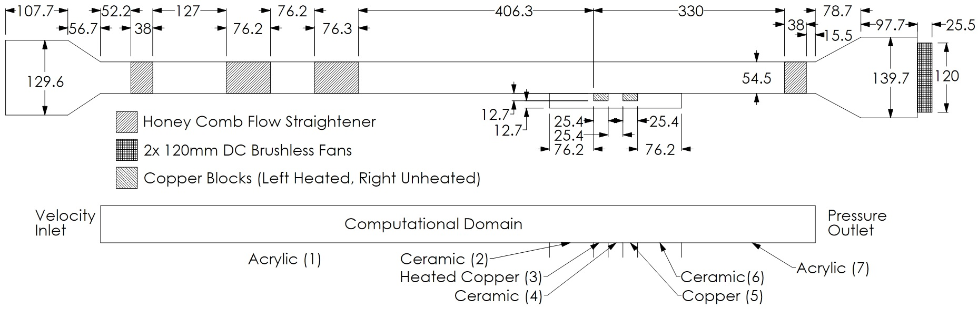

Figure 1. Wind tunnel schematic.

The plume source is a 25.4mm wide electrically heated copper plate embedded in an aero-gel and ceramic base. Two such copper blocks exist in the test section separated by 25.4mm. Only the upstream block is heated in this research; however, the high thermal conductivity of the second copper block affects the results and needs to be explained. Two K-type thermocouples are located within the copper block approximately 1.0mm below the surface.

A Pitot-static tube located downstream of the test section is used to determine free stream velocity. The Pitot-static tube is attached to a NIST traceable differential pressure sensor from Omega, model PX655-0.1DI.

A custom thermocouple probe used for data collection is located in a 2D traversing mechanism above the centerline of the test section. The thermocouple is a standard K-type probe with an exposed tip of 40gage wire. All data is recorded using a National Instruments data acquisition board.

Y

X

# SIMULATIONS

The Navier-Stokes equations were solved for air using a three-dimensional, steady state, realizable k-ε model with enhanced wall effects via the software package Fluent (Fluent version 13 from Ansys). Density was approximated using the ideal gas law at constant pressure of $P_{∞}=101.6kPa$ Specific heat at constant pressure was constant at $c_{p}=1006.43J/{(kg-K)}$. In an effort to reduce the simulation error with respect to the experiment dynamic viscosity and thermal conductivity are defined by the Chapman-Enscog equations with constant Lennard-Jones parameters of $σ=3.711Å$ and $E/k=78.6K$, Vincenti [1965], Fluent [2010].

The computational domain is the entire wind tunnel between the converging and diverging sections. The flow straighteners are not modeled. The three-dimensional domain is interpreted as two-dimensional with symmetric boundary conditions into and out of the page. The upstream edge of the plume source along the center line of the wind tunnel is identified as $x=0mm, y=0mm$. Domain discretization yield 130292cells. Grid spacing of $∆x$ and $∆y$ are between $0.175mm$ and $2.0mm$. Grid spacing perpendicular to the flow $∆z$ is between $0.75mm$ and $2.0mm$. The pressure and velocity are coupled. Pressure is discretized to second order, while all others are third order MUSCL.

The inflow boundary conditions are the velocity ${ U}_{∞}$, static temperature $T_{∞}$, static pressure $P_{∞}$, and zero entry turbulence. The uppermost boundary is identified as symmetric. The outlet is a pressure-outflow boundary condition. The bottom boundary condition consists of seven zones, from left to right: acrylic wall, ceramic wall, heated copper plate, ceramic wall, copper plate, ceramic wall, acrylic wall. All of the zones are treated as conjugate heat transfer of $12.7mm$ thick and outer temperature of $T_{∞}$ (except for the heated copper plate, which has a outer temperature of $T_{S}$). The material properties are constant and the ceramic has a density, specific heat, and thermal conductivity of $2320kg/m^{3}$, $1138J/{(kg-K)}$, and $0.1$ W⁄(m-K) respectively.

To use a hybrid approach to solving the inverse convection problem the numerical solutions must closely match. Therefore, a numerical-experimental validation is necessary. Table 1 contains a list of parameters used during the validation, with the experimental errors. Figure 2 is a comparison of the experiment and numerical data at a cross section of X=40mm. Figure 3 is a similar comparison at X=60mm. It is evident that closer the sampling to the x-axis, the more accurate the simulation tends to be. This is very acceptable as the data near the region of interest where the bulk of the plume resides is more accurate. The maximum error is less than 2% and often less than 1%.

Table 1

Validation Test Summary

|  |  |
| --- | --- |
| Parameter | Value |
| $$U_{∞}({cm}/s)$$ | $$6.0±0.15$$ |
| $$T_{∞}(K)$$ | $$294.5±2.0$$ |
| $$P_{∞}(kPa)$$ | $$101.6±0.2$$ |
| $$T_{S}(K)$$ | $$433±2.0$$ |

# METHODOLOGY

During initial investigations into the inverse convection problem, sensitivity analysis revealed a linear relationship between local temperature and source temperature, for constant free stream velocity. Figure 4 is an example of a sensitivity analysis at (30,4)mm with a linear curve fit. The coefficients of this linearity are non-linear with respect to spatial coordinates and need to be recalculated for each location of interest. This presents no problems if two simulations of identical grid and free stream velocities, but differing source temperatures are available.

A priori knowledge of the free stream velocity will be assumed from this point forward. Start by selecting two appropriate simulations with source temperatures near the unknown source temperature of interest. They will be identified as source temperature of simulation A and simulation B respectively $T_{SA}$, $T_{SB}$. Similarly, local temperatures of the simulations are $T_{A}(x,y)$ and $T_{B}\left(x,y\right).$ Next select n samples from the unknown source experiment. Since the location of the source is unknown only the relative location between samples is relevant. One sample is chosen as a datum with location at $x_{1},y_{1}$ and the other locations are identified by ${∆x}_{i},{∆y}_{i}$ relative to the datum.

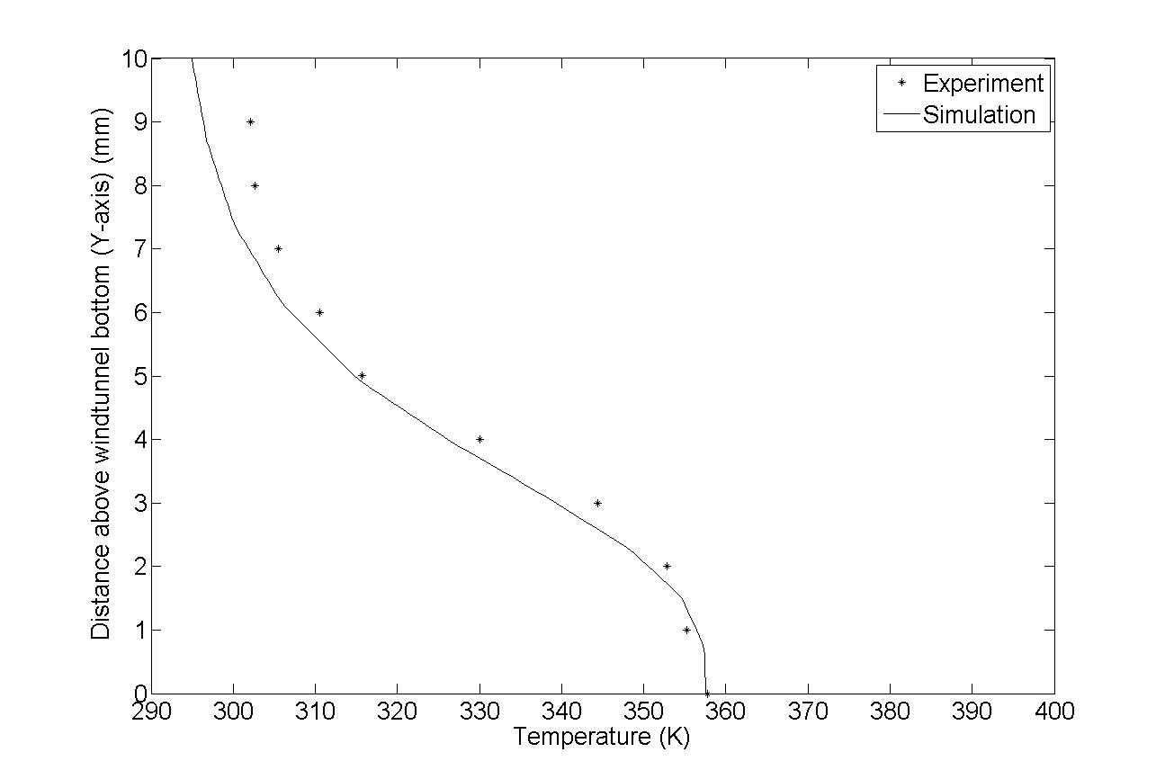

Figure 2. Experiment and numerical comparison at X=40mm.

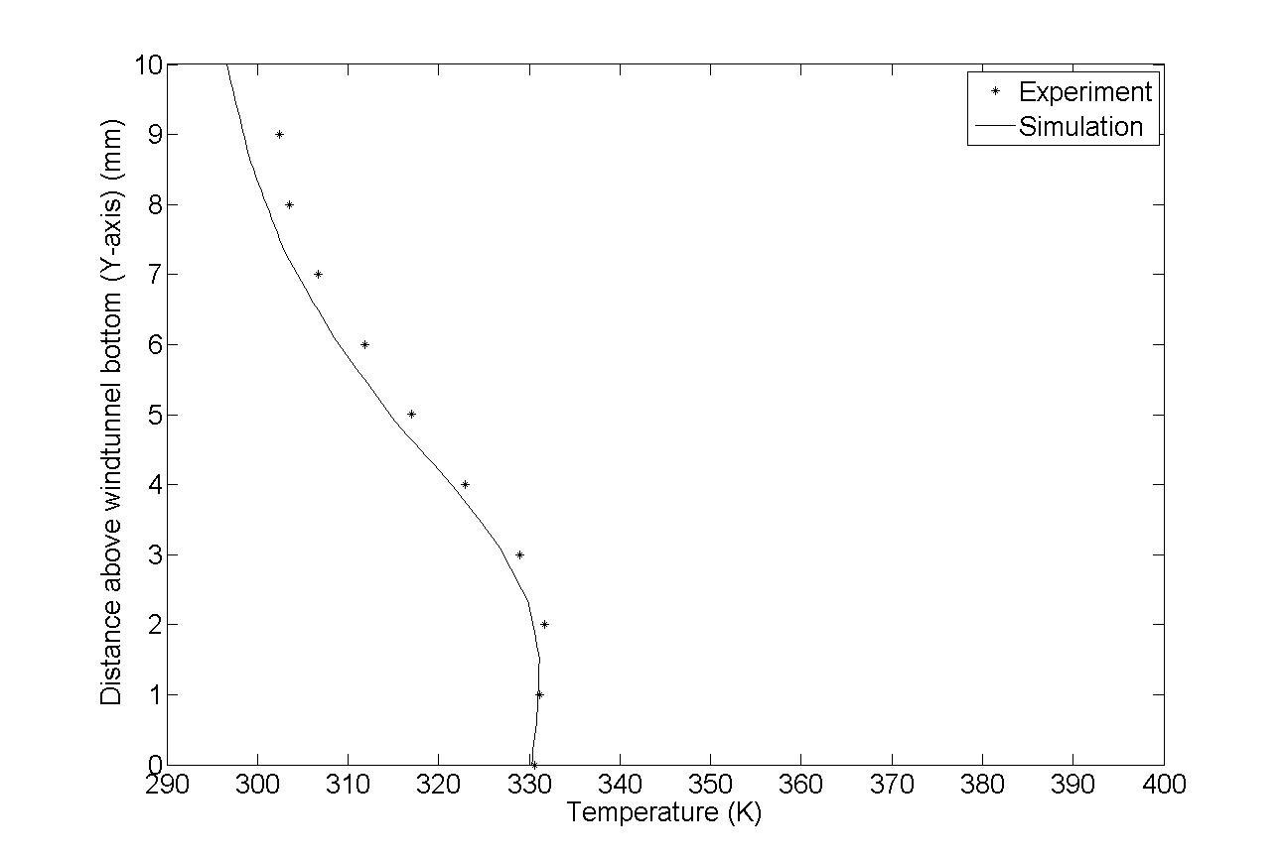

Figure 3. Experiment and numerical comparison at X=60mm.

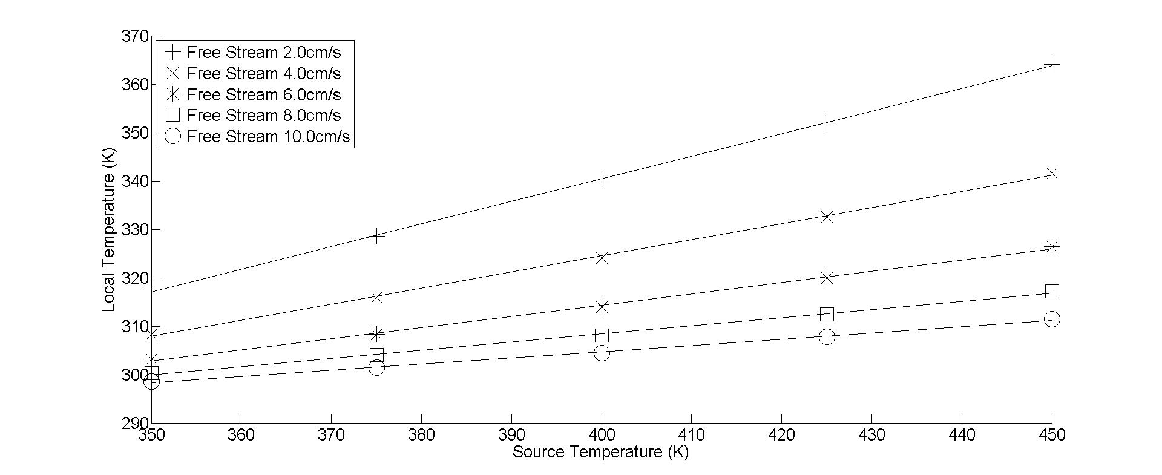

Figure 4. Sensitivity analysis of local temperature vs. source temperature

The datum relationship is as follows:

|  |  |
| --- | --- |
| $$x_{i}=x_{1}+{∆x}_{i} \\ y_{i}=y_{1}+{∆y}_{i}$$ | ( 1 )  ( 2 ) |

The linear relationship between the local temperature and source can be described as:

|  |  |
| --- | --- |
| $$T_{S}=m\left(x,y\right)T\left(x,y\right)+b\left(x,y\right) \\ m\left(x,y\right)=\frac{T_{SA}-T_{SB}}{T_{A}\left(x,y\right)-T_{B}\left(x,y\right)} \\ b\left(x,y\right)=T_{SA}-m\left(x,y\right)T_{A}\left(x,y\right)$$ | ( 3 )  ( 4 )  ( 5 ) |

This methodology makes the assumption: only one solution may predict identical source temperatures for a set of samples and relative locations. If this is true, and at least in the case of the plume in a cross wind it seems to be then the sum of the errors of predicted source temperature may be used to predict one ideal solution. Minimization of equation 6 leads to a least squares problem and is solved using the genetic algorithm

|  |  |
| --- | --- |
| $$E(x,y)=\sum_{i=2}^{n}{{\begin{aligned}\left[m\left(x+{∆x}_{i},y+{∆y}_{i}\right)T\left(x_{i},y_{i}\right)+b\left(x+{∆x}_{i},y+{∆y}_{i}\right)-m\left(x,y\right)T\left(x_{1},y_{1}\right)-b\left(x,y\right)\right]\end{aligned}}^{2}}$$ | ( 6 ) |

The x and y resulting in a minimum of E are $x_{SP}^{*},y_{SP}^{*}$. The source temperature can then be calculated by:

|  |  |
| --- | --- |
| $$T_{SP}=\frac{\sum_{i=1}^{n}{\begin{aligned}\left[m\left(x_{SP}^{*}+{∆x}_{i},y_{SP}^{*}+{∆y}_{i}\right)T\left(x_{i},y_{i}\right)+b\left(x_{SP}^{*}+{∆x}_{i},y_{SP}^{*}+{∆y}_{i}\right)\right]\end{aligned}}}{n}$$ | ( 7 ) |

To increase the accuracy of the predicted location this process may be repeated with new samples and a slightly modified objective function:

|  |  |
| --- | --- |
| $$E_{mod}(x,y)=\sum_{i=1}^{n}{{\begin{aligned}\left[m\left(x+{∆x}_{i},y+{∆y}_{i}\right)T\left(x_{i},y_{i}\right)+b\left(x+{∆x}_{i},y+{∆y}_{i}\right)-T_{S}\right]\end{aligned}}^{2}}$$ | ( 8 ) |

The genetic algorithm is used to minimize the new objective function, whose minimum occurs at $(x_{SP},y_{SP})$

# RESULTS

With no firm indication of how the experimental samples should be oriented; another sensitivity analysis was performed comparing predicted source temperature error to vertical/ horizontal orientation and spacing of samples; similarly, predicted location error to vertical/ horizontal orientation and spacing. A portion of the results are shown in figure 5a-d. From figure 5a and 5b it is clear that both orientations, any spacing, and any number of samples (greater than 3) gives acceptable temperature predictions. Horizontal spacing of four or more samples with 1.5mm spacing gives best results for source temperature predictions. For location prediction it is evident from figure 5c that greater than 1.5mm spacing, vertical orientation and at least four samples gives better than 10% error.

Location prediction via information gained of horizontally spaced samples is erratic at best as displayed in figure 5d. It is useful to note the results shown in figure 5c,d are error of $x_{SP}^{*},y_{SP}^{*}$ not $x_{SP},y_{SP}$.

|  |  |
| --- | --- |
| Figure 5a. Temperature prediction error vs vertical spacing between samples | Figure 5b. Temperature prediction error vs horizontal spacing between samples |
| Figure 5c. Location prediction error vs vertical spacing between samples | Figure 5d. Location prediction error vs horizontal spacing between samples |

Figure 6. Sample pattern

Datum Sample Point (reused between stages)

Stage 2 Samples

Stage 1 Samples

From the sensitivity analysis the recommended samples should be four samples arranged horizontally with 1.5mm spacing to predict the source temperature and four samples arranged vertically with 1.5mm spacing to predict the location of the source. Assuming sample points are reusable between the first and second stage, seven samples are required to accurately predict the location and temperature of the source. The sampling shape and datum location are shown in figure 6.

To test the effectiveness of the algorithm, simulated data was first used negating the effects of experiment-numerical differences. Ten randomly generated source locations were produced using the following parameters for the simulations.

Table 2

Simulated Test Parameters

|  |  |
| --- | --- |
| Parameter | Value |
| $$U_{∞}({cm}/s)$$ | $$6.0$$ |
| $$T_{∞}(K)$$ | $$293$$ |
| $$P_{∞}(kPa)$$ | $$101.32$$ |
| $$T_{S}(K)$$ | $$425$$ |
| $$T_{SA}, T_{SB} (K)$$ | $$350, 450$$ |
| $$Possible X range$$ | $25-80 in 5mm$ increments |
| $$Possible Y range$$ | $0-5mm in 1mm$ increments |
| $$n stage 1$$ | $$4$$ |
| $$n stage 2$$ | 4 |
| $$∆x, ∆y stage 1$$ | $$1.5mm,0mm$$ |
| $$∆x,∆y stage 2$$ | $$0mm,1.5mm$$ |

Figure 7 shows the results of said test, in every case the results are similar. The predicted source temperature error is below 0.1%, first stage location error is generally poor (above 10% error), and second stage location error drops to less than 5% in all cases. The location indicated is the location of the datum sample with respect to the source.

Running the same algorithm with experimental measurements reveals promising results. Two separate experiments were run except with differing free stream velocities $6.0cm/s$ and $8.0cm/s$ and slightly differing sample locations. Table 3 summarizes the parameters used for the first experiment, while table 4 contains the results. Table 5 summarizes the parameters for the second experiment, and table 6 contains the results.

Table 3

Experiment 1 Parameters

|  |  |
| --- | --- |
| Parameter | Value |
| $$U_{∞}({cm}/s)$$ | $$6.0±.15$$ |
| $$T_{∞}(K)$$ | $$294.5±2.0$$ |
| $$P_{∞}(kPa)$$ | $$101.6±0.2$$ |
| $$T_{S}(K)$$ | $$428±2.0$$ |
| $$T_{SA}, T_{SB} (K)$$ | $$350, 450$$ |
| $$n stage 1$$ | $$4$$ |
| $$n stage 2$$ | 4 |
| $$∆x, ∆y stage 1$$ | $$1.0mm,0mm$$ |
| $$∆x,∆y stage 2$$ | $$0mm,1.0mm$$ |

Table 4

Experiment 1 Results

|  |  |  |  |  |
| --- | --- | --- | --- | --- |
| Location  x,y (mm) | | Source Temperature  Prediction Error (%) | Location Error  First Stage (%) | Location Error  Second Stage (%) |
| 35,1 | 1.29 | | 26.0 | 2.91 |
| 40,1 | 1.24 | | 23.8 | 5.80 |
| 45,1 | 1.40 | | 21.1 | 3.80 |
| 50,1 | 0.573 | | 3.80 | 1.13 |

Table 5

Experiment 2 Parameters

|  |  |
| --- | --- |
| Parameter | Value |
| $$U_{∞}({cm}/s)$$ | $$8.0±.15$$ |
| $$T_{∞}(K)$$ | $$294.5±2.0$$ |
| $$P_{∞}(kPa)$$ | $$101.5±0.2$$ |
| $$T_{S}(K)$$ | $$431±2.0$$ |
| $$T_{SA}, T_{SB} (K)$$ | $$350, 450$$ |
| $$n stage 1$$ | $$4$$ |
| $$n stage 2$$ | 4 |
| $$∆x, ∆y stage 1$$ | $$1.0mm,0mm$$ |
| $$∆x,∆y stage 2$$ | $$0mm,1.0mm$$ |

Table 6

Experiment 2 Results

|  |  |  |  |  |
| --- | --- | --- | --- | --- |
| Location  x,y (mm) | | Source Temperature  Prediction Error (%) | Location Error  First Stage (%) | Location Error  Second Stage (%) |
| 35,0 | 0.120 | | 17.7 | 5.89 |
| 40,0 | 1.02 | | 24.0 | 1.25 |
| 45,0 | 0.991 | | 35.8 | 1.42 |
| 50,0 | 5.41 | | 42.2 | 9.73 |

# CONCLUSIONS

A methodology developed from a sensitivity analysis and regularization techniques has been applied to both simulations and experiments with promising results. Error acknowledge by testing the methodology to simulations reveal error of less than 0.1% for predicting source temperature and 5% for predicting source location. Compounding errors of experiment and experiment-numerical differences have reduced the accuracy to the order of 1% error for predicting source location, with one exception. The experiment predicted source location error is approximately 5%. As required only a small set of total sample locations is required to achieve useable results. In the cases described only seven sample locations were required.

This methodology allows for many further investigations. Some such investigations are: in depth analysis on sample size, shape, and orientation; additional research on removing the a priori knowledge of free stream velocity, which has been found to be quadratically related to local temperature. Among other things, this methodology allows itself to be applied to many inverse convection problems, including natural convection and jet in a cross flow problems.

# REFERENCES

Carvel, R.O. and Beard, A.N. and Jowitt, P.W. and Drysdale, D.D. [2001], Variation of Heat Release Rate with Forced Longitudinal Ventilation for Vehicle Fires in Tunnels, *Fire Safety J.*, Vol. 36, pp 569-596.

Fluent Technical Documents v13.0 [2010], Ansys, Inc

Hu, L.H. andYang, D. [2009], Large Eddy Simulation of Fire-Induced Buoyance Driven Plume Dispersion in an Urban Street Canyon Under Perpendicular Wind Flow, *J. of Hazardous Materials*, Vol. 166, pp 394-406.

Mokhtarzadeh-Dehghan, M.R. and König, C.S. and Robins, A.G. [2006], Numerical Study of Single and Two Interacting Turbulent Plumes in Atmospheric Cross Flow, *Atmospheric Environment*, Vol. 40, pp 3909-3923.

Orlande, H. and Fudyam, O. and Maillet, D. and Cotta, R. [2011], *Thermal Measurements and Inverse Techniques*, CRC Press, Boca Raton, Florida.

Özisik, M. and Orlande, H. [2000], *Inverse Heat Transfer: Fundamentals and Applications*, Taylor & Francis, New York, New York.

Rudman, M. [1996], Simulation of the Near Field of a Jet in a Cross Flow, *Exp. Thermal and Fluid Sci.*, Vol. 12, pp 134-141.

Tikhonov, A. and Arsenin, V. [1977], *Solutions of Ill-Posed Problems*, V.H.Winston & Sons, Washington D.C.

Vincenti, W. and Kruger, C. [1965], *Introduction to Physical Gas Dynamics*, Krieger Publishing Co., Malabar, Florida.